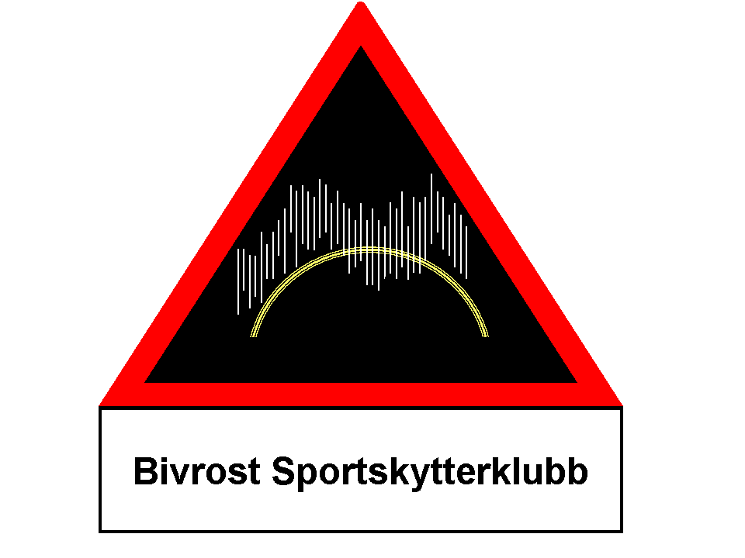

Bivrost SSK
INVITES TO
NORDIC CHAMPIONSHIPS
PISTOL 2013

DATE: Thursday 01.08.2013 - Sunday 04.08.2013
PLACE: Kongsberg metallic silhouette shooting range, Kongsberg (approximately 100 km west of Oslo) along road E-18 to E-134, GPS: N 59.38.393 E 9.30.331
ENTRIES: On the attached entry form per e-mail to the Match Director (see below) no later than 18.07.2013. The start schedule will be sent to the contact person for each country noted on the entry form.
PRACTICE: Wednesday 31.07.2013 10:00 – 17:00
NUMBER OF ENTRIES: Each shooter may enter all categories if the time permits.
START TIME: Thursday - Saturday 9:00-17:00, Sunday 9:00-12:00
Shoot-offs on Sunday 04.08.2013 start 13:00 or as soon as ready
AWARD CEREMONY: After shoot-offs, Sunday 04.08.2013
ENTRY FEES: NOK 200,- per entry (no fees for aggregate), NOK 300,- for each team. All fees are paid at the range before first entry.
CATEGORIES: SMALL BORE BIG BORE FIELD PISTOL
Revolver Revolver Production
Conventional Conventional Production Any Sight
Production Production Aggregate
Unlimited Unlimited
Standing Standing
4 gun aggregate 4 gun aggregate
(First entry of conventional or production will be included in aggregate)
TEAM
3 men teams in Small Bore, Big Bore and Field Pistol Aggregate
NUMBER OF SHOTS: 40 + 5 sighting in shots. Shoot off will be 5 shots first round, then 5 shots.
GUN CHECK: If necessary.
FOOD: Self service kiosk at the range: hotdogs, sandwiches, soft drinks. Grill will be available, bring your own barbecue food.
LODGING: Hotels/hostels in Kongsberg or camping at the range.
AWARDS: NMF medals to the three overall winners in each category. 1st-3rd in each class (Int, A, B) will be awarded trophies if sufficient number of entries.
RESULTS: Will be sent by mail to the contact person for each country noted on the entry form.
GENERAL: IMSSU rules apply. Nordic Conventional Rules apply: Conventional must be shot with a non-bolt action Production gun. Conventional class must be shot first if the same gun is used for Production.
OTHER: Shooters/spotters must help with setting targets. Some ground sheets are available. Shooters must bring their own gun boxes for the range.
MATCH DIRECTOR: Nikolay Mustaparta: nmustapa@yahoo.com

ALL NORDIC METALLIC SILHOUETTE SHOOTERS ARE VERY WELCOME!

